Breast Cancer Prediction Deployment using Flask

Submitted By:Tapasya
Internship:AI & Machine Learning Internship
Project Type:Model Deployment — Flask API
Technologies Used:Python, Flask, Machine Learning, HTML/CSS
Submission Date:May 2026

2. Introduction
Machine Learning models become useful in real-world applications when they are deployed and made accessible to users through web applications or APIs. Model deployment is the process of integrating trained machine learning models into software systems so that predictions can be generated in real time.
In this project, a breast cancer prediction system was developed using Flask, a lightweight Python web framework. The application accepts medical feature inputs from users through a web interface and predicts whether the tumor is benign or malignant using a trained machine learning model.
The main objective of this project is to demonstrate:
- machine learning model deployment
- frontend and backend integration
- real-time prediction systems
- Flask web development
- AI-powered healthcare applications

3. Project Objectives
The objectives of this project are:
- To deploy a trained machine learning model using Flask
- To create an interactive web interface for prediction
- To connect frontend and backend systems
- To generate real-time prediction results
- To visualize prediction confidence using charts
- To understand practical AI deployment workflow

4. Dataset Description
The model used in this project was trained using the Breast Cancer Wisconsin Dataset.
The dataset contains medical measurements extracted from digitized images of breast mass cell nuclei. These measurements help classify tumors as malignant or benign.
Dataset Features
The dataset contains 30 numerical features including:
- Radius Mean
- Texture Mean
- Perimeter Mean
- Area Mean
- Smoothness Mean
- Compactness Mean
- Concavity Mean
- Symmetry Mean
- Fractal Dimension
The target variable predicts:
- Malignant Tumor
- Benign Tumor
Dataset Source:
https://www.kaggle.com/datasets/uciml/breast-cancer-wisconsin-data

5. Technologies Used
Technology | Purpose
Python | Programming language
Flask | Web framework
Scikit-learn | Machine learning
NumPy | Numerical operations
Joblib | Model loading
HTML/CSS | Frontend interface
Chart.js | Data visualization

6. System Architecture
The system architecture consists of three main components:
1. Frontend
The frontend was developed using HTML and CSS. It provides:
- input forms
- prediction interface
- confidence visualization
- responsive dashboard
2. Backend
The backend was developed using Flask. It:
- receives user input
- processes data
- loads ML model
- generates predictions
- sends results back to frontend
3. Machine Learning Model
A trained breast cancer classification model was used for prediction. The model processes 30 medical input features and predicts cancer classification.

7. Implementation
Step 1 — Model Loading
The trained model file (breast_cancer_model.pkl) was loaded using Joblib.
model = joblib.load('models/breast_cancer_model.pkl')

Step 2 — User Input Collection
Users enter medical feature values through the web form.
The Flask application receives form data using:
request.form.values()

Step 3 — Prediction Generation
The model predicts whether the tumor is:
- benign
- malignant
Prediction confidence percentage is also calculated using:
predict_proba()

Step 4 — Visualization
Chart.js was integrated to display:
- benign probability
- malignant probability
- prediction confidence chart

8. Features of the System
The developed system includes:
- Real-time cancer prediction
- Interactive medical dashboard
- Flask-based deployment
- Prediction confidence percentage
- Pie chart visualization
- Professional healthcare UI
- Machine learning integration

9. Results
The application successfully:
- loads the trained ML model
- accepts medical feature inputs
- predicts breast cancer classification
- displays prediction confidence
- visualizes prediction probabilities
The Flask application worked successfully in a local deployment environment and generated prediction results in real time.
Add Screenshots Here:
- homepage
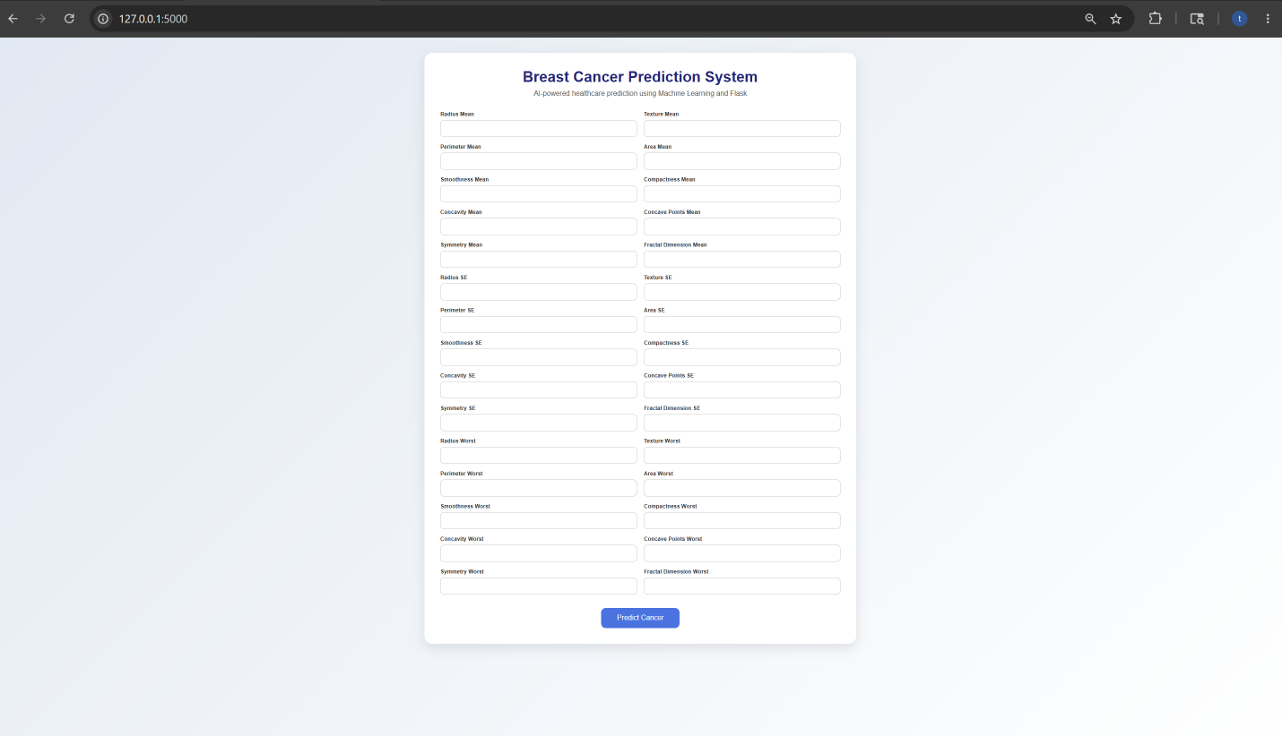

- prediction and result
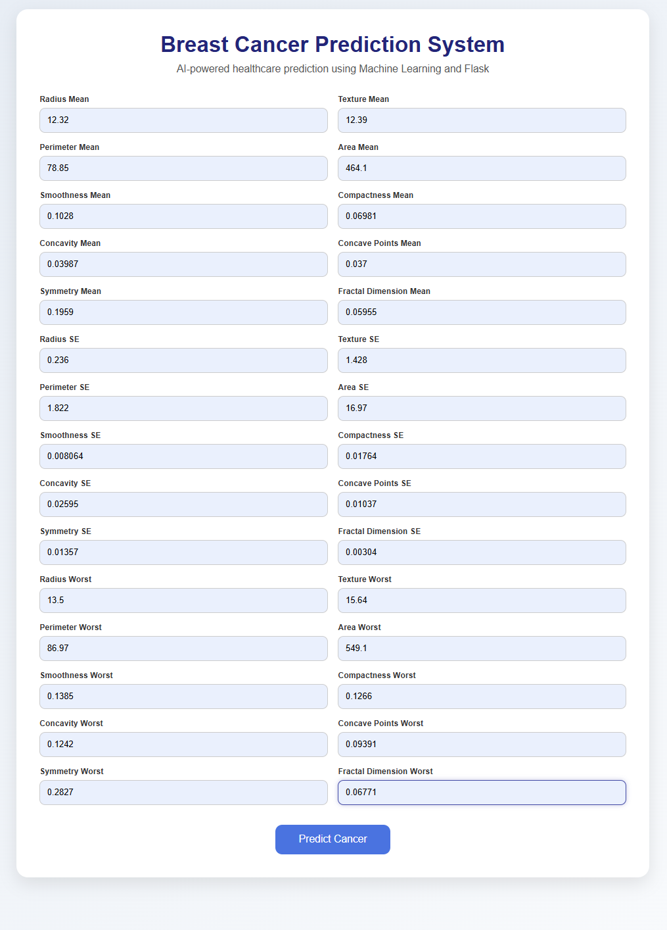


- Flask server terminal
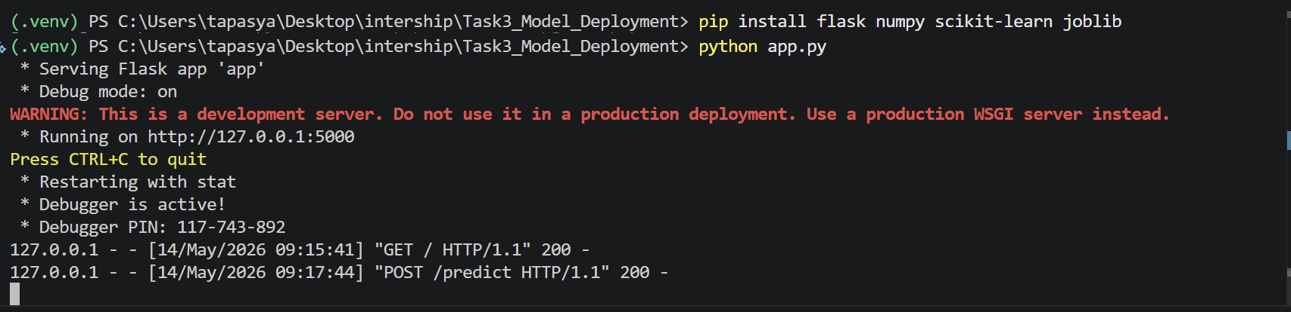

10. Challenges Faced
During development, several challenges were encountered:
- Flask route handling issues
- HTML template rendering problems
- feature mismatch errors
- prediction probability integration
- UI responsiveness improvements
These issues were resolved through debugging and testing.

11. Future Improvements
The project can be improved by:
- deploying on cloud platforms
- integrating real hospital datasets
- improving model accuracy
- adding user authentication
- implementing advanced deep learning models
- adding downloadable reports
- improving medical visualization

12. Conclusion
This project successfully demonstrated deployment of a machine learning model using Flask. The developed application combines machine learning, frontend development, backend integration, and data visualization into a complete AI-powered healthcare prediction system.
The project provided practical experience in:
- AI deployment
- Flask development
- web application integration
- machine learning serving
- healthcare AI systems
Overall, the project successfully fulfilled the objectives of real-time machine learning deployment and healthcare prediction.

13. References
- Flask Official Documentation
- Scikit-learn Documentation
- Breast Cancer Wisconsin Dataset
- Chart.js Documentation
- Python Official Documentation

